Chamber Blue of Kansas Communication Templates

Please use the content examples below when announcing your involvement with the Chamber Blue of Kansas. These are examples only, so feel free to customize for your platform and audience.

Press Release
FOR IMMEDIATE RELEASE

Contact:
Chamber contact name Title
Phone Email

Rebecca Witte
Blue Cross and Blue Shield of Kansas Public Relations Specialist
785-291-6559
rebecca.witte@bcbsks.com

Local Businesses have Opportunity to Join Chamber Health Insurance Plan
Chamber Blue of Kansas helps make insurance more affordable for business owners

City, Kansas (Month, Date, Year) – The Chamber Name has partnered with Blue Cross and Blue Shield of Kansas (BCBSKS) and the Chamber of Commerce Executives of Kansas (CCEKS) to offer businesses access to health insurance savings associated with large group medical coverage.
Chamber Blue of Kansas is an association health plan (AHP) that allows for employers to join together to purchase insurance. The larger pool of people enrolled in the plan allows the possibilities for more plan options, and potentially, lower cost.
“Quote from Chamber president/representative discussing the excitement to be able to offer this to members.”
The plan is open to employers who have two or more employees and are current, dues- paying members of the Chamber Name.
Chamber Blue of Kansas offers employers the ability to attract and retain top talent by increasing access and buying power of more than a single business alone. Employers and their most valued asset – their employees – will receive access to:
- A dedicated account management team with one-on-one support
- More choice in plan options

- Stability of rates with a larger pool of participants
- A uniform rate for the group based on average risk rather than rating each member individually
- Dental, life, disability and ancillary coverage offerings will be available to complete your benefit package
“Optional quote from chamber member about how this program will improve their ability to serve their employees.”
To learn more about how you can help your employees improve their overall health and well-being, contact Chamber contact name, title, phone number.

Chamber Boilerplate

About Chamber of Commerce Executives of Kansas
As a private not-for-profit 501(c)6, Chamber of Commerce Executives of Kansas (CCEKS) operates with the primary goal of serving its membership by providing excellence in professional development, networking, resources, and idea exchange opportunities. Also, CCEKS provides guidance and leadership training to chambers across the state and the board members who serve in local communities. For more information, visit cceks.org.

About Blue Cross and Blue Shield of Kansas:
For 80 years, Blue Cross and Blue Shield of Kansas has built a reputation of trust with its members and contracting providers by providing outstanding customer service while quickly and accurately processing claims; fairly administering benefit plans and contracts; offering programs, services and tools to help members improve or maintain their health; and operating under the highest ethical standards while being good stewards of premium dollars. Blue Cross and Blue Shield of Kansas is an independent licensee of the Blue Cross Blue Shield Association and is the state’s largest insurer, serving all Kansas counties except Johnson and Wyandotte.
For more information, visit bcbsks.com.

Blue Cross and Blue Shield of Kansas is an independent licensee of the Blue Cross Blue Shield Association. Chamber Name is not affiliated with Blue Cross and Blue Shield of Kansas.

# # #

Newsletter/Article/Website
We’re excited to announce the [insert Chamber name] is partnering with the Chamber of Commerce Executives of Kansas and Blue Cross and Blue Shield of Kansas to form the Chamber Blue of Kansas. This new association health plan will be available to all chamber members in good standing and who employ two or more W2 employees.

The Chamber Blue of Kansas is focused on providing more value to business owners and their employees. With more health insurance plan options at competitive rates, employers can provide rich benefits, helping attract and retain top talent.

Learn more at bcbsks.com/chamberblueks.

Image:

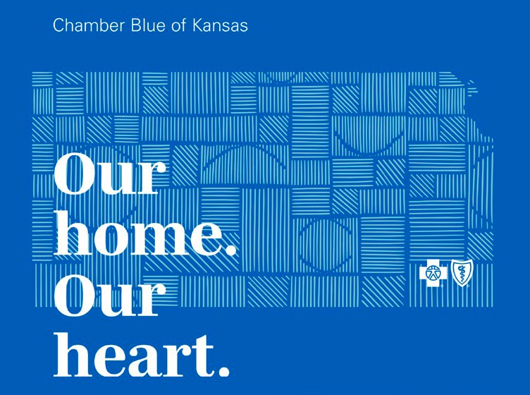

Email template to inform Chamber members of participation

Good [morning],

I’m happy to announce the [insert Chamber name] is partnering with the Chamber of Commerce Executives of Kansas and Blue Cross and Blue Shield of Kansas to form the Chamber Blue of Kansas. This new association health plan will be available to all chamber members in good standing and who employ two or more W2 employees.

The Chamber Blue of Kansas is focused on providing more value to business owners and their employees. With more health insurance plan options at competitive rates, you can provide rich benefits, helping attract and retain top talent.

If you choose to participate in the Chamber Blue of Kansas, Blue Cross will provide a dedicated account management team located right here in Kansas to help you implement the health plan. They will provide one-on-one support, training for your human resource staff, benefit assistance, and education for your employees.

Timing
Here are a few dates to keep in mind:
- August 2022: An interest survey will be conducted. The survey is mandatory and must be completed to guarantee your business’s participation in the AHP
- September 2022: Rates will be announced
- October 2022: Enrollment begins with the support of Blue Cross
- January 2023: Coverage begins

For more information, visit bcbsks.com/chamberblueks.

If you have additional questions, please contact [Chamber representative] and they will connect you with a Blue Cross representative.

We look forward to this partnership and how it will help provide a healthy foundation for businesses and their employees. Thank you!

